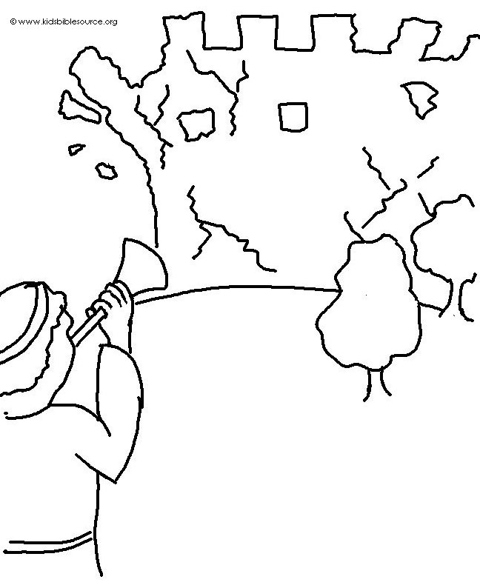
Yes, the _ _ _ _ has done _ _ _ _ _ _ _ things for us! What joy! Psalm 126:3_{NLT}

